Get Covered 2021 Partner Posts

Thanks for being part of Get Covered 2021! Below are sample posts your organization can share on or soon after our launch date of November 19. Please refer to our broader Get Covered 2021 Digital Toolkit for more posts (available at https://getcovered2021.org/about-us/).

Post: We know how essential it is that everyone has access to affordable health care coverage. That’s why we’re joining #GetCovered2021 to remind Americans to get insured and stay healthy. Learn more: GetCovered2021.org
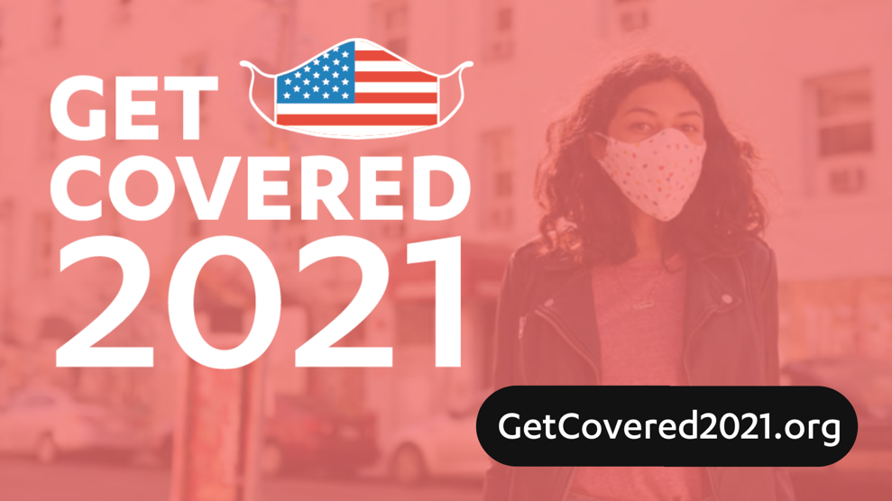

Download: Graphics for Twitter / Graphics for Facebook/Instagram

Post: The Affordable Care Act is a lifeline for millions of Americans. We’re thrilled join #GetCovered2021 to encourage all Americans to sign up for affordable health care today. Learn more and find a plan: GetCovered2021.org
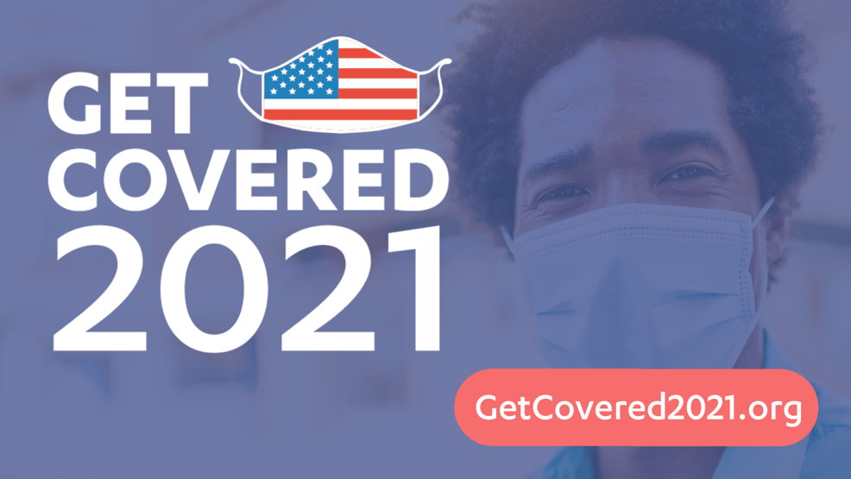

Download: Graphics for Twitter / Graphics for Facebook/Instagram

Post: We’re joining #GetCovered2021! It’s a national effort committed to advancing the extraordinary opportunity to build on the Affordable Care Act so everyone can have access to affordable quality coverage and care. GetCovered2021.org
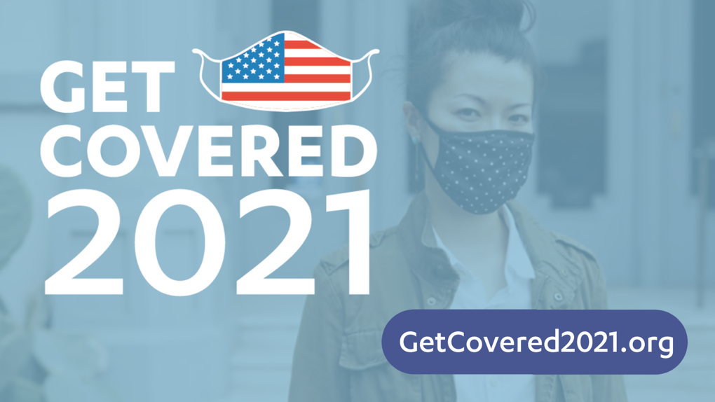

Download: Graphics for Twitter / Graphics for Facebook/Instagram

